DATA ANALYTICS WITH TABLEAU

ASSIGNMENT-2

1.DONUT CHART

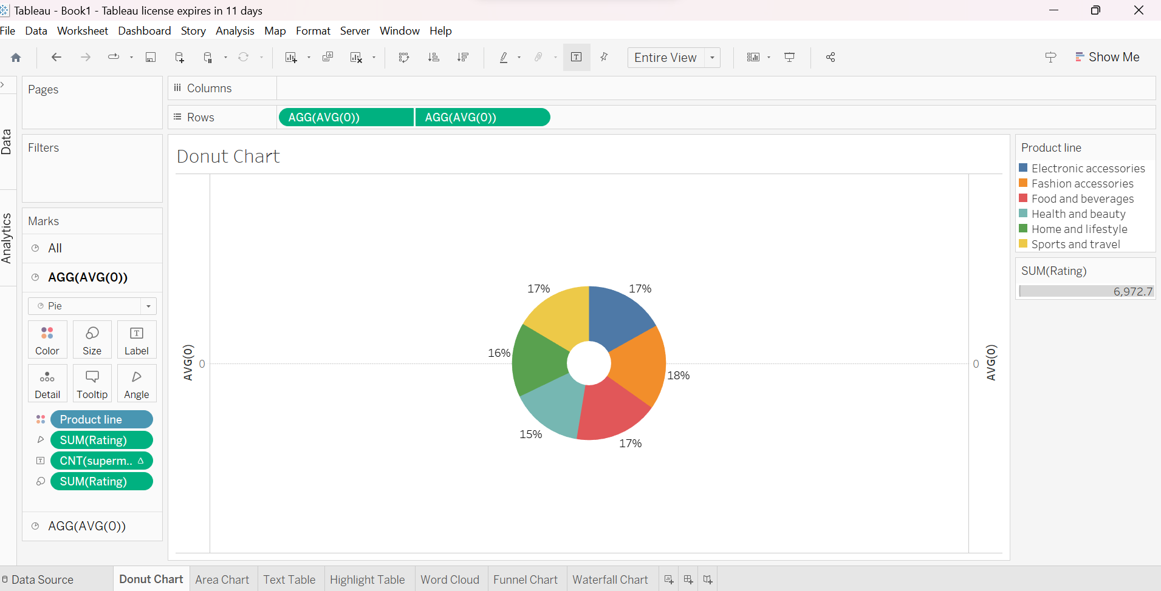

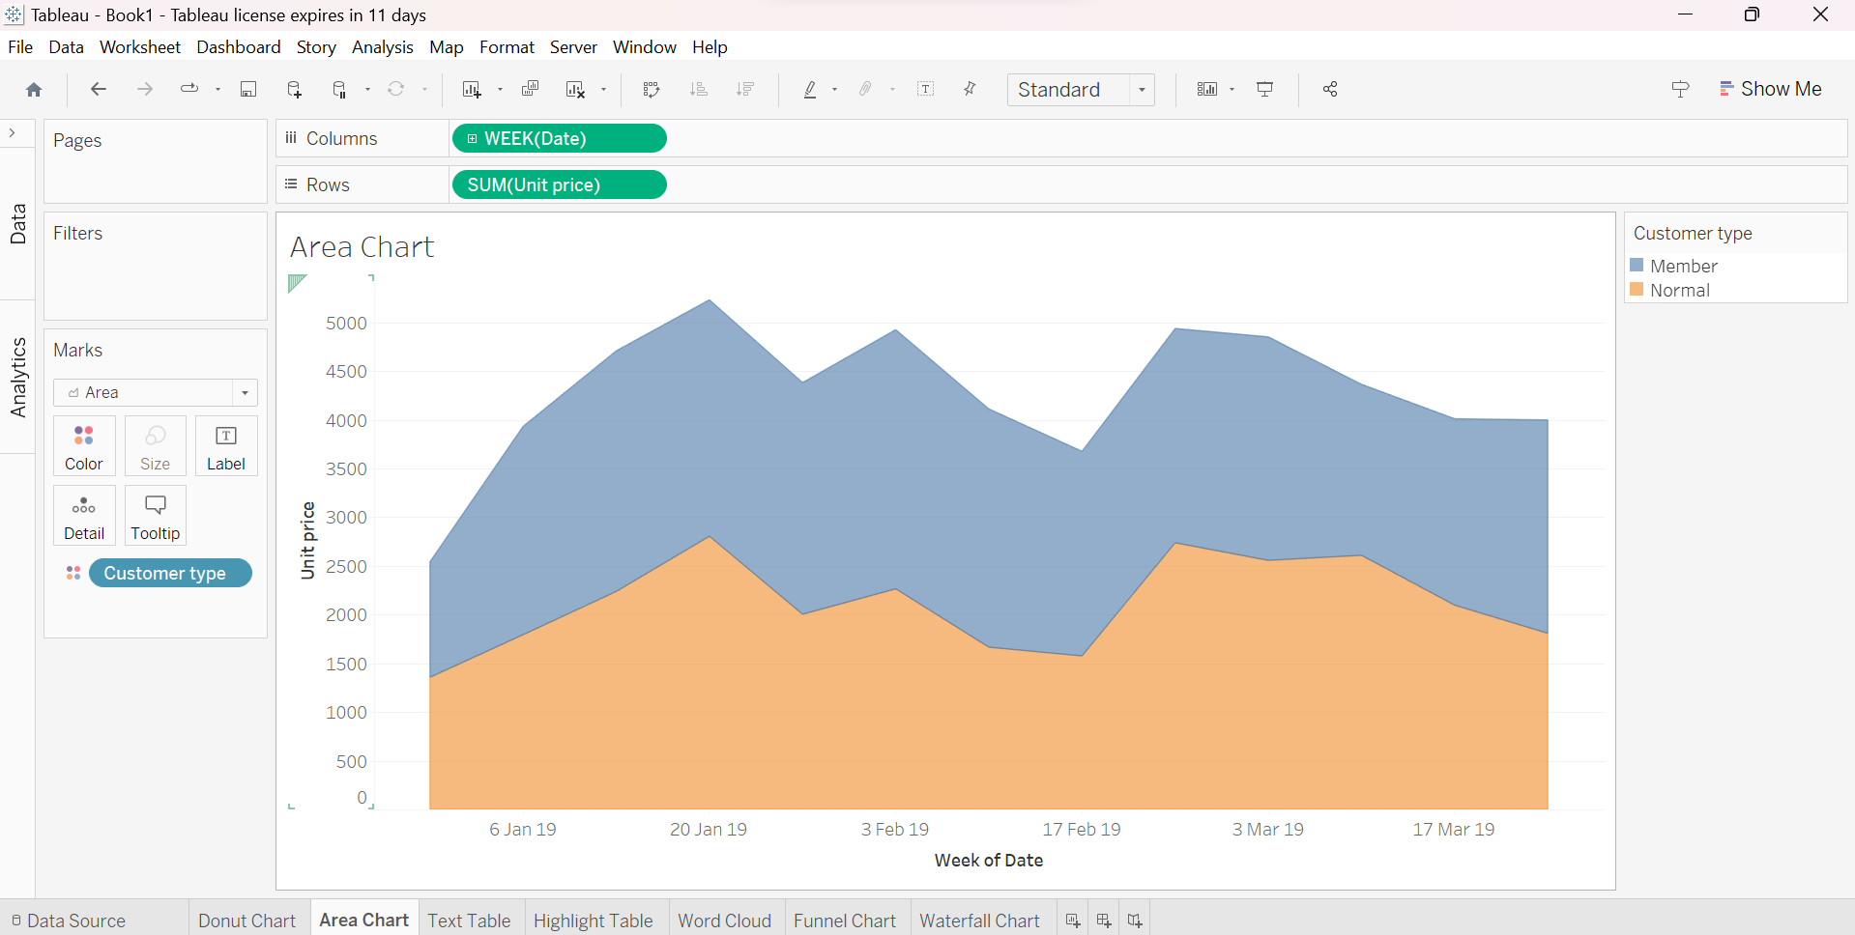2.AREA CHART

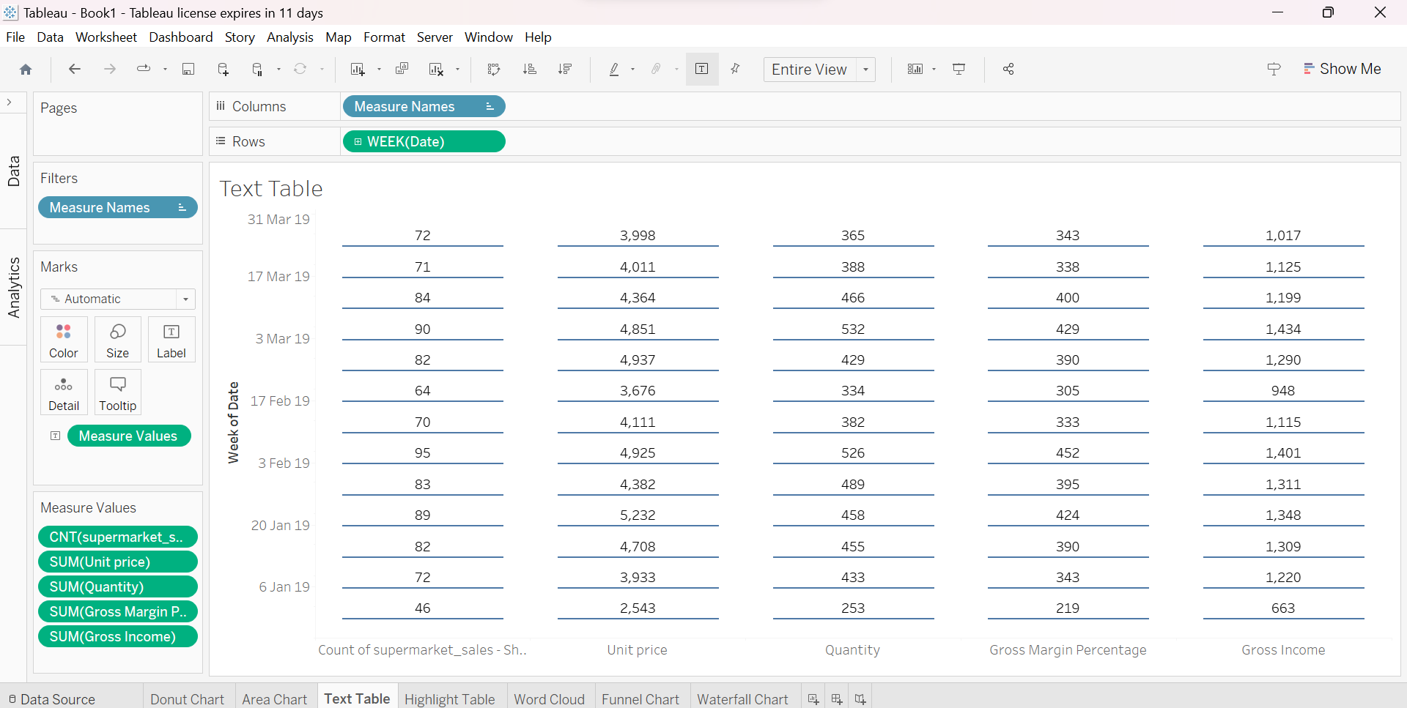3.TEXT TABLE

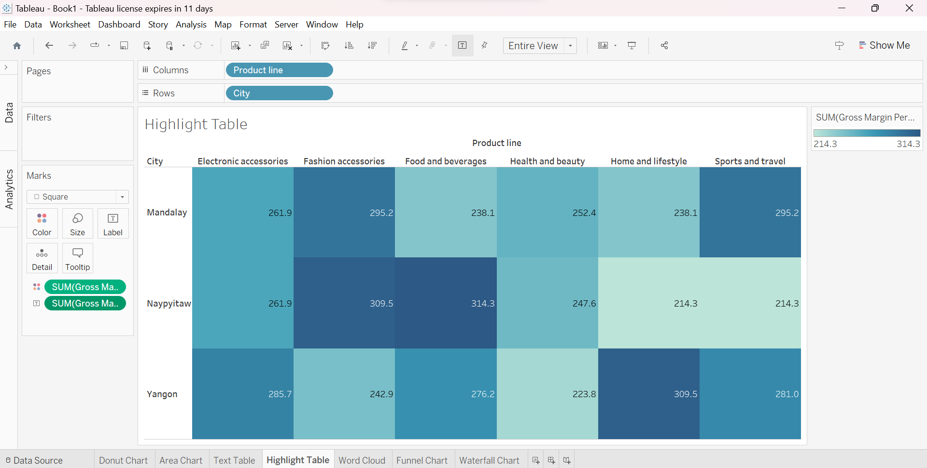4.HIGHLIGHTED TABLE

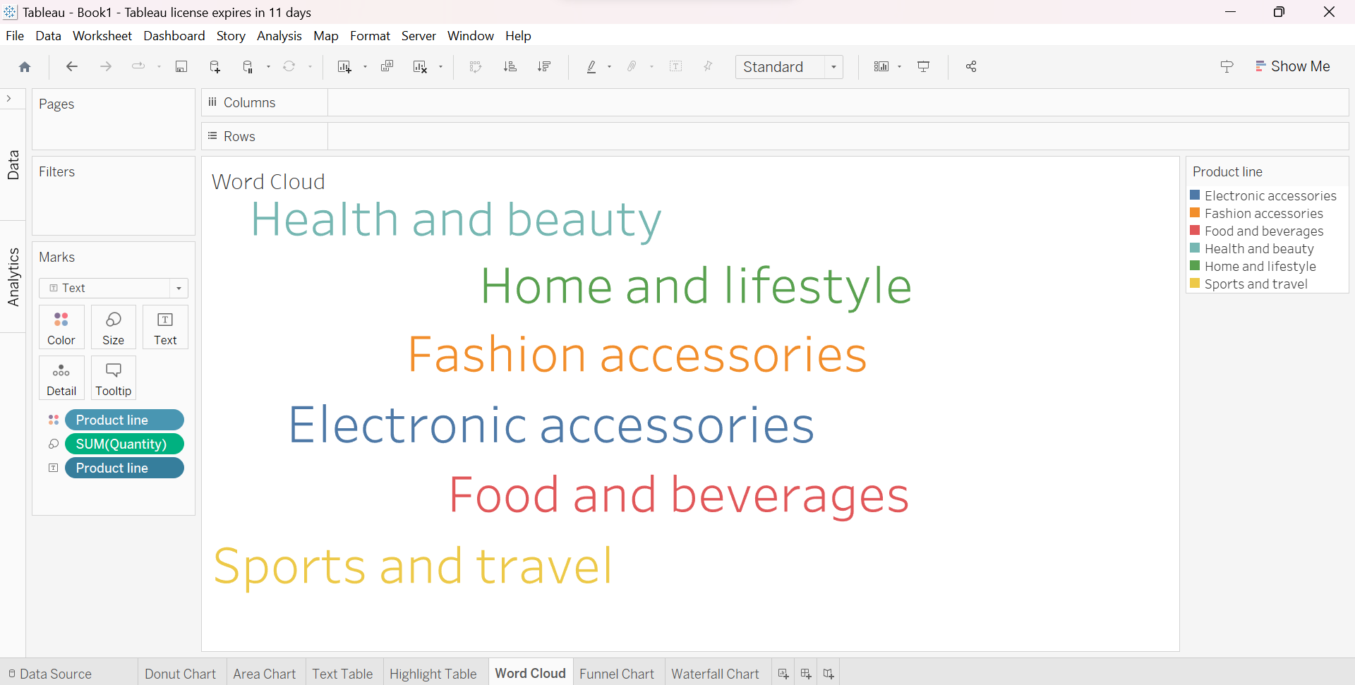5.WORD CLOUD

6.FUNNEL CHART

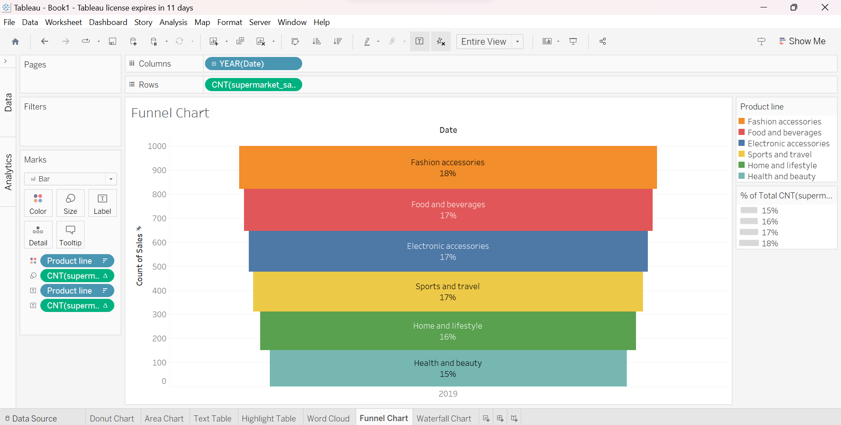

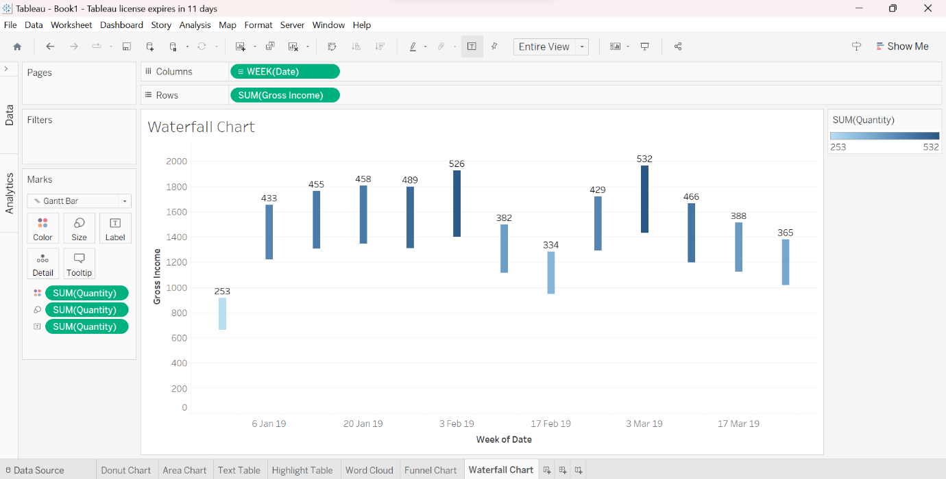7.WATERFALL CHART